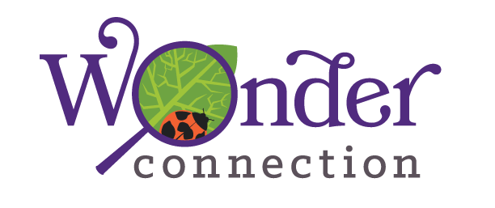

(formerly Healing and Hope through Science)
North Carolina Botanical Garden- UNC
Student Science Enrichment Program (SSEP) Grant Progress Report
September 2016-August 2017
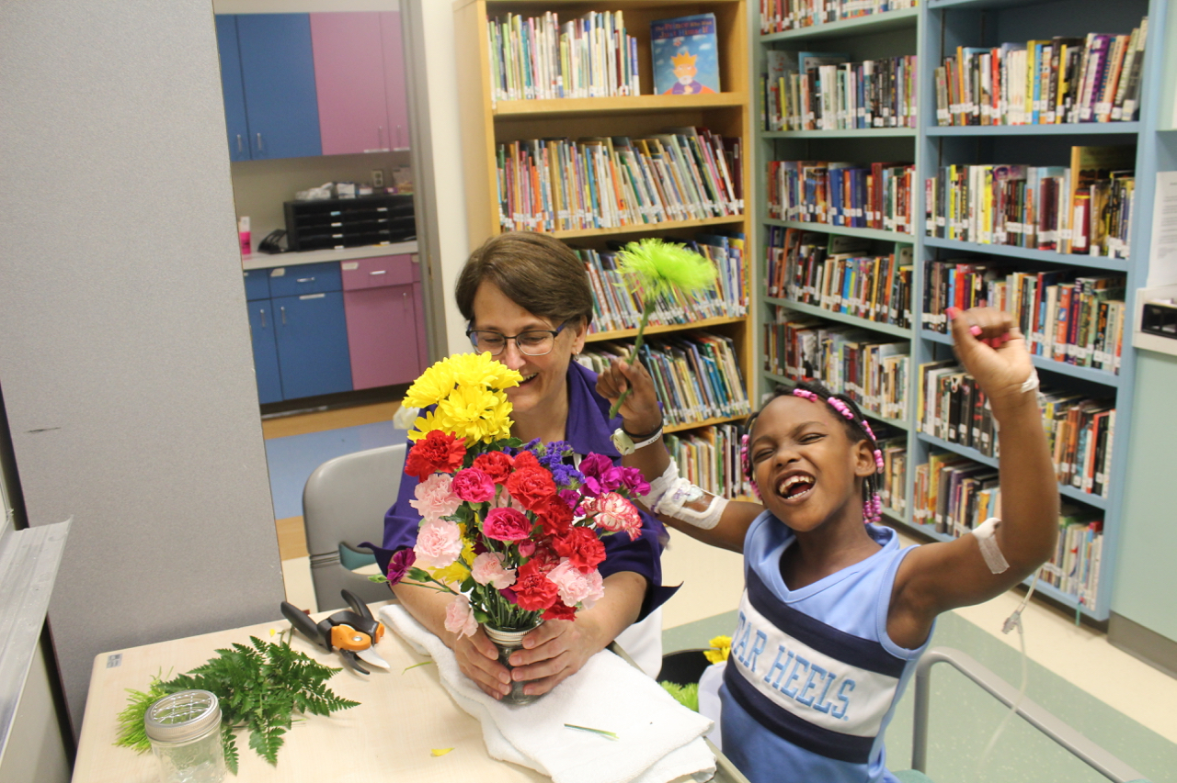
September 30, 2017

Prepared by:
Katie Stoudemire
Andrew Torlage
Mary Faith Mount-Cors

Executive Summary
Background

Wonder Connection is a program of The University of North Carolina’s (UNC) Botanical Garden (NCBG) in Chapel Hill. With support from the Burroughs Wellcome Fund (BWF), this one-of-a-kind program provides hospitalized children with a connection to the natural world via hands-on natural science activities. The program includes experiential science classes, visiting scientists, and other science-related activities for both pediatric and psychiatric patients aged 3 to 18 years in 2017, as a continuation of programming from 2013. Wonder Connection has been active since 2008 and has benefited from BWF support since 2013. A yearly evaluation is supplied to BWF as part of the Student Science Enrichment Program (SSEP) to report on progress toward the four goals seen below.
- Goal 1: Increase students’ competence in science by strengthening their science process skills (including observation, communication, classiﬁcation, measurement, inference and prediction) and their insight into and appreciation of the investigative process.
- Goal 2: Nurture students’ enthusiasm for science & their interest in science-related careers.
- Goal 3: Stimulate students’ positive emotions.
- Goal 4: To support the above listed goals and increase individual pediatric patients’ contact hours within the program.
This evaluation report provides data analysis and interpretation related to these four goals.
Methodology
This evaluation used surveys to pose questions related to each goal to students after participation in Wonder Connection programming. Parents were also surveyed after their students/children participated if they had been present for the Wonder Connection session. Respondents answered questions online or used a paper version of the survey depending on the circumstances. Wonder Connection collected 134 regular student surveys, 64 student surveys following visiting scientist sessions and 19 parent surveys from June 2017 to September 5, 2017. Open-ended questions on all surveys provided additional descriptive data about children’s experiences with Wonder Connection.
Highlights of Key Findings

Goal 1: Students’ competence in the science process and insight into the investigative process increased.
- 100% of students cited positive examples of science learning.

Goal 2: Students’ enthusiasm for science increased.
- 100% of parents answered yes to the survey question “Did Wonder Connection stimulate your child’s interest in science?”
- 98% of students reported that the activities were fun
- After participating in a Wonder Connection session, almost 94% of students said they would like to do more science like what they did today.
- After participating in a Wonder Connection visiting scientist session, over 98% of students said they would like to learn more about doing this kind of science.

Goal 3: Students’ experienced positive emotions as a result of Wonder Connection activity.
- 94% of students reported feeling ‘happy’ after the Wonder Connection session.
- Almost 94% reported feeling ‘interested’ after participating in a Wonder Connection session.
- About 80% of students confirmed that they felt better after the session than they had before they participated in the session.
- 100% of parents said their child felt ‘happy’ and ‘interested’ after the Wonder Connection session.

Goal 4: Individual pediatric patients’ contact hours increased within the program.
- They served 23 pediatric patients for 5 or more contact hours (and seven patients for 10+hours). The average number of contact hours per pediatric patient increased to 3.5

Student Participation
Population Served | # of unique individuals | # of contact hours | Average Contact Time
Pediatric Patients | 183 | 634 | 3.5 hours (an increase of 1 contact hour/student from last year)
Child/Adolescent Psychiatric Patients | 238 | 422 | 2 hours
Outpatients | 114 kids, 159 adults | 273 | 1 hour
Total | 694 | 1329

Evaluation
Wonder Connection worked with an external evaluator, Mary Faith Mount-Cors, Ph.D., to develop this section of the report. Dr. Mount-Cors was hired in order to conduct data analysis, write up findings, and provide recommendations for program enhancement.
Table 3: Evaluation Data Sources

Data Source | Sample | Number of Data Records
Student Surveys after Wonder Connection session | Pediatric & psychiatric inpatients and outpatients aged 3-18 | 134
Student Surveys after Visiting Scientist session | Pediatric & psychiatric inpatients and outpatients aged 3-18 | 64
Parent Survey | Parents  (who attended the entire session of a Wonder Connection student) | 19

Goal 1: Hospitalized children will increase their competence in science by strengthening their science process skills (including observation, communication, classiﬁcation, measurement, inference and prediction) and their insight into and appreciation of the investigative process.

Student Survey Questions Related to Goal 1

Question 8 on the survey asked students to describe what they learned about science and nature in their Wonder Connection class session.

Out of the 125 students who responded, 72% said they observed something. Meanwhile, 60% said that they had made something new, about 20% that they had used a science tool and 16% that they had measured something. Student responses to this question appear in Table 4 below and some of the descriptive data included in some students’ responses is included under Table 4.

Table 4. Impact on Students’ Science Learning
 | Student Question 8: Describe what you learned or did today. (Choose as many as you want). (125 children responded)
Categories of Children’s Responses |  | Number | Percentage
I observed (looked at) something  I made something new  I used a science tool (like a microscope).  I measured something. |  | 90  75  26  20 | 72%  60%  20.80%  16%

Some of the qualitative data collected in response to this question included:
Boy, Age 8: “Blood cells carry from heart to you veins”
Girl, Age 4: “Learned how volcanoes erupt”
Girl, Age 10: “I made slime, it was amazing. I learned not to put too much of your ingredients in the mix for the slime or it could get messed up”
Boy, Age 15: “How plants work”
Girl, Age 13: “We pretended we were eating as birds”
Boy, Age 5: “Dig for fossils using tools”
Boy, Age 8: “I thought about my project and how I could do it different to better next time. I used technology, I met a scientist. Water and Alka Seltzer in a little jar will make it shoot out like a rocket”.
Goal 1 Interpretation
Goal 1: Increase students’ science competence and ability to perform science process skills
Indicator(s) | Applied to | Data Source | Data Interval | Target
# and % of participants who develop an interest in and knowledge of natural sciences & increase their science process skills | Students | Student Survey | After programming | 80%
Results
Student report: 100% of students who responded cited one or more responses about what they learned or did in their Wonder Connection session related to building science competence and the ability to perform science process skills.

Goal 2 Nurture student enthusiasm for science & their interest in science-related careers.

Questions are designed to capture evidence on nurturing students’ enthusiasm for science and determine the amount of change the program achieves in student science enthusiasm.

Student Survey Questions Related to Goal 2
Question 7 received 127 responses, with almost 94% of students saying that they would like to do more science like the activity they did that day. The answer breakdown is included in the table below.

Student Question 7 | A lot | Some | A little | Not at all
Would you like to do more science like the activity we did today? | 68.50% | 18.90% | 6.30% | 6.30%
This year, an additional short survey tool was used with students following each visiting scientist session. Question 2 of the Student’s Visiting Scientist Survey asked: Would you like to learn more about doing this kind of science? This question received 64 responses, with over 98% of responses saying they would to learn more about doing this kind of science.

Student’s Visiting Scientist Survey Question 2 | A lot | Some | A little | Not at all
Would you like to learn more about doing this kind of science? | 67.19% | 21.88% | 9.38% | 1.56%

To gauge enthusiasm and interest, the regular student survey also contained a question about whether the student had fun doing their activity in the Wonder Connection session. Question 5 on the regular student survey received 131 responses, with over 98% of the students saying that what they did today was fun. The answer breakdown is included in the table below.

Student Question 5 | A lot | Some | A little | Not at all
Which hands-on activity did you do today? Was it fun? | 73.28% | 19.08% | 6.11% | 1.53%

Parent Survey Data Related to Goal 2
100% or all 19 parents who responded to “Did Wonder Connection stimulate your child’s interest in science?” answered yes, mostly, almost 95%, saying ‘a lot’. Parents included comments such as: “This really put a smile on Joe’s face and he is looking forward to the next project” and “Now he is extremely interested in science!”

Goal 2 Nurture students’ enthusiasm for science
Indicator(s) | Applied to | Data Source | Data Interval | Target
# and % of participants who report an interest in natural sciences and desire for more science education | Students Parents | Surveys | After programming | 80%
Results
Over 98% of students reported that the Wonder Connection was fun. After participating in a Wonder Connection session, almost 94% of students said they would like to do more science like what they did today. After participating in a Wonder Connection visiting scientist session, over 98% of students who responded said they would like to learn more about doing this kind of science.

Goal 3- Stimulate positive emotions for pediatric patients at the NC Children’s Hospital.

Students responded to survey questions about their emotions. In addition, parents responded to questions related to Goal 3.
Student Survey Questions Related to Emotions
In past years, the program used a pre-survey to gauge student emotions before the Wonder Connection session and a post-survey to look at the change in emotions directly following the session. An increase in positive emotions and a decrease in negative emotions were regularly found. This year, the pre-survey was eliminated as these same shifts could be gauged by asking one recall question and then examining students’ emotions after the Wonder Connection session.
On Question 6, students were asked: How do you feel now after doing this activity? One hundred thirty-three students responded and the spread of responses on two positive emotions: Happy and Interested and two negative emotions: Sad and Bored are seen in the table. 94% of students reported feeling some gradation of ‘happy’ (from a lot to a little) and almost 94% reported feeling some gradation (from a lot to a little) of ‘interested’ after participating in a Wonder Connection session. More than 86% of students said they did not feel ‘sad’ at all and about 80% did not feel ‘bored’ at all.
Student Question 6
How do you feel now after doing this activity? | A lot | Some | A little | Not at all
Happy | 63.33% | 20.83% | 10% | 5.83%
Interested | 58.40% | 24% | 11.20% | 6.40%
Sad | 1.80% | 3.60% | 8.11% | 86.49%
Bored | 1.77% | 4.42% | 14.16% | 79.65%

In addition, Question 3 asked students how they felt after the Wonder Connection session in relation to how they felt before it. With the session being about one hour long, this was an immediate recall of how they felt before the Wonder Connection session compared to now. One hundred nineteen student responses were received, with almost 80% of students feeling better than before the session, and close to 20% feeling the same. Only two students responded that they felt worse than before the session.

Student Question 3 | Better than before | Same as before | Worse than before
Compared to how you felt BEFORE today’s session, how do you feel now? | 78.99% | 19.33% | 1.68%

Parent Survey Questions Related to Goal 3

Parents were also asked: How did your child feel while doing this activity? The same four emotions were offered to the parents as with the students: Happy, Interested, Sad, and Bored. One hundred percent of the parents said their child felt ‘happy’ and 100% of parents said their child felt ‘interested’. Also, 100% of parents said their child did not feel ‘bored’ at all while almost 95% said their child did not feel ‘sad’ at all, with just 5% saying that their child felt ‘a little sad’.

In addition, one parent’s comment illustrated the positive experience of the program for her child: “A wonderful program to take my son’s mind off everything going on while admitted.”

Goal 3 Data:
Goal 3: Stimulate students’ positive emotions
Indicator(s) | Applied to | Data Source | Data Interval | Target
# and % of participants who report positive emotions | Students  Parents | Survey | After programming | 80%
Results

94% of students reported feeling some gradation of ‘happy’ (from a lot to a little) and almost 94% reported feeling some gradation (from a lot to a little) of ‘interested’ after participating in a Wonder Connection session. More than 86% of students said they did not feel ‘sad’ at all and about 80% did not feel ‘bored’ at all. About 80% confirmed that they felt better after the session than they had before they participated in the session. 100% of parents said their child felt ‘happy’ and ‘interested’.

Goal 4 To support the above listed goals and increase individual pediatric patients’ contact hours within the program.

Wonder Connection served 23 pediatric patients for 5 or more contact hours and seven patients for 10+hours. The average number of contact hours per pediatric patient increased to 3.5 hours/patient during this reporting period.

